OBJECT ORIENTED PROGRAMMING
UNIT –II
Concept of reference-:When a variable is declared as a reference, it becomes an alternative name for an existing variable. A variable can be declared as a reference by putting ‘&’ in the declaration.
Also, we can define a reference variable as a type of variable that can act as a reference to another variable. ‘&’ is used for signifying the address of a variable or any memory. Variables associated with reference variables can be accessed either by its name or by the reference variable associated with it.

Example

#include <iostream>
using namespace std;

int main()
{
int x = 10;

// ref is a reference to x.
int& ref = x;

// Value of x is now changed to 20
ref = 20;
cout << "x = " << x << '\n';

// Value of x is now changed to 30
x = 30;
cout << "ref = " << ref << '\n';

return 0;
}

Applications of Reference in C++
There are multiple applications for references in C++, a few of them are mentioned below:
- Modify the passed parameters in a function
- Avoiding a copy of large structures
- In For Each Loop to modify all objects
- For Each Loop to avoid the copy of objects

New and delete Operators in C++ For Dynamic Memory
Dynamic memory allocation in C/C++ refers to performing memory allocation manually by a programmer. Dynamically allocated memory is allocated on Heap, and non-static and local variables get memory allocated on Stack
- Static allocation or compile-time allocation - Static memory allocation means providing space for the variable. The size and data type of the variable is known, and it remains constant throughout the program.
- Dynamic allocation or run-time allocation - The allocation in which memory is allocated dynamically. In this type of allocation, the exact size of the variable is not known in advance. Pointers play a major role in dynamic memory allocation.
Dynamically we can allocate storage while the program is in a running state, but variables cannot be created "on the fly". Thus, there are two criteria for dynamic memory allocation -
- A dynamic space in the memory is needed.
- Storing the address to access the variable from the memory
Similarly, we do memory de-allocation for the variables in the memory.
In C++, memory is divided into two parts -
- Stack - All the variables that are declared inside any function take memory from the stack.
- Heap - It is unused memory in the program that is generally used for dynamic memory allocation.

new operator
The new operator denotes a request for memory allocation on the Free Store. If sufficient memory is available, a new operator initializes the memory and returns the address of the newly allocated and initialized memory to the pointer variable.
The “new” operator in C++ is used to allocate memory dynamically for a variable or an object at runtime. This means that the memory is allocated during the execution of the program, as opposed to being allocated at compile time. When the “new” operator is called, it reserves a block of memory that is large enough to hold the object being created and then returns a pointer to the first byte of that memory block.

Example
#include <iostream>
#include <memory>
using namespace std;

int main()
{
// pointer to store the address returned by the new
int* ptr;
// allocating memory for integer
ptr = new int;

// assigning value using dereference operator
*ptr = 10;

// printing value and address
cout << "Address: " << ptr << endl;
cout << "Value: " << *ptr;

return 0;
}
Initialize memory: We can also initialize the memory for built-in data types using a new operator. For custom data types, a constructor is required (with the data type as input) for initializing the value. Here’s an example of the initialization of both data type.

delete operator
Since it is the programmer’s responsibility to deallocate dynamically allocated memory, programmers are provided delete operator in C++ language.
The “delete” operator is used to deallocate memory that the “new” operator previously allocated. Once a block of memory has been allocated by “new,” it is important to deallocate it when it is no longer needed so that other parts of the program can reuse the memory. The “delete” operator releases the memory back to the system, and other parts of the program can use it.
Note: Use delete to deallocate memory allocated with new to avoid memory leaks.

Example

#include <iostream>
using namespace std;

int main()
{
// Pointer initialization to null
int* p = NULL;

// Request memory for the variable
// using new operator
p = new (nothrow) int;
if (!p)
cout << "allocation of memory failed\n";
else {
// Store value at allocated address
*p = 29;
cout << "Value of p: " << *p << endl;
}

// Request block of memory
// using new operator
float* r = new float(75.25);

cout << "Value of r: " << *r << endl;

// Request block of memory of size n
int n = 5;
int* q = new (nothrow) int[n];

if (!q)
cout << "allocation of memory failed\n";
else {
for (int i = 0; i < n; i++)
q[i] = i + 1;

cout << "Value store in block of memory: ";
for (int i = 0; i < n; i++)
cout << q[i] << " ";
}

// freed the allocated memory
delete p;
delete r;

// freed the block of allocated memory
delete[] q;

return 0;
}

Inline Functions in C++
C++ provides inline functions to reduce the function call overhead. An inline function is a function that is expanded in line when it is called. When the inline function is called whole code of the inline function gets inserted or substituted at the point of the inline function call. This substitution is performed by the C++ compiler at compile time. An inline function may increase efficiency if it is small.
Remember, inlining is only a request to the compiler, not a command. The compiler can ignore the request for inlining.
The compiler may not perform inlining in such circumstances as:
- If a function contains a loop. (for, while and do-while)
- If a function contains static variables.
- If a function is recursive.
- If a function return type is other than void, and the return statement doesn’t exist in a function body.
- If a function contains a switch or goto statement.

Inline functions Advantages:
- Function call overhead doesn’t occur.
- It also saves the overhead of push/pop variables on the stack when a function is called.
- It also saves the overhead of a return call from a function.
- When you inline a function, you may enable the compiler to perform context-specific optimization on the body of the function. Such optimizations are not possible for normal function calls. Other optimizations can be obtained by considering the flows of the calling context and the called context.
- An inline function may be useful (if it is small) for embedded systems because inline can yield less code than the function called preamble and return.
Example

#include <iostream>
using namespace std;
inline int cube(int s) { return s * s * s; }
int main()
{
cout << "The cube of 3 is: " << cube(3) << "\n";
return 0;
}

Function Overloading
Function overloading is a feature of object-oriented programming where two or more functions can have the same name but different parameters. When a function name is overloaded with different jobs it is called Function Overloading. In Function Overloading “Function” name should be the same and the arguments should be different. Function overloading can be considered as an example of a polymorphism feature in C++.
If multiple functions having same name but parameters of the functions should be different is known as Function Overloading.
If we have to perform only one operation and having same name of the functions increases the readability of the program.
Suppose you have to perform addition of the given numbers but there can be any number of arguments, if you write the function such as a(int,int) for two parameters, and b(int,int,int) for three parameters then it may be difficult for you to understand the behavior of the function because its name differs.

Example

#include <iostream>
using namespace std;

void add(int a, int b)
{
cout << "sum = " << (a + b);
}

void add(double a, double b)
{
cout << endl << "sum = " << (a + b);
}

// Driver code
int main()
{
add(10, 2);
add(5.3, 6.2);

return 0;
}

Default Arguments
A default argument is a value provided in a function declaration that is automatically assigned by the compiler if the calling function doesn’t provide a value for the argument. In case any value is passed, the default value is overridden.
The following is a simple C++ example to demonstrate the use of default arguments. Here, we don’t have to write 3 sum functions; only one function works by using the default values for 3rd and 4th arguments.
If function overloading is done containing the default arguments, then we need to make sure it is not ambiguous to the compiler, otherwise it will throw an error. The following is the modified version of the above program:

A constructor can contain default parameters as well. A default constructor can either have no parameters or parameters with default arguments.
// CPP Program to demonstrate Default Arguments
Example

#include <iostream>
using namespace std;
int sum(int x, int y, int z = 0, int w = 0) //assigning default values to z,w as 0
{
return (x + y + z + w);
}
int main()
{
cout << sum(10, 15) << endl;
cout << sum(10, 15, 25) << endl;
cout << sum(10, 15, 25, 30) << endl;
return 0;
}

Constructor

Constructor in C++ is a special method that is invoked automatically at the time an object of a class is created. It is used to initialize the data members of new objects generally. The constructor in C++ has the same name as the class or structure. It constructs the values i.e. provides data for the object which is why it is known as a constructor.

Characteristics of Constructors in C++
- The name of the constructor is the same as its class name.
- Constructors are mostly declared in the public section of the class though they can be declared in the private section of the class.
- Constructors do not return values; hence they do not have a return type.
- A constructor gets called automatically when we create the object of the class.
There can be three types of constructors in C++.
- Default constructor
- Parameterized constructor
- Copy constructor

Default Constructor
A constructor which has no argument is known as default constructor. It is invoked at the time of creating object.
Let's see the simple example of C++ default Constructor.
#include <iostream>
using namespace std;
class Employee
{
public:
Employee()
{
cout<<"Default Constructor Invoked"<<endl;
}
};
int main(void)
{
Employee e1; //creating an object of Employee
Employee e2;
return 0;
}

Parameterized Constructor

A constructor which has parameters is called parameterized constructor. It is used to provide different values to distinct objects.
Let's see the simple example of C++ Parameterized Constructor.
#include <iostream>
using namespace std;
class Employee {
public:
int id;//data member (also instance variable)
string name;//data member(also instance variable)
float salary;
Employee(int i, string n, float s)
{
id = i;
name = n;
salary = s;
}
void display()
{
cout<<id<<" "<<name<<" "<<salary<<endl;
}
};
int main(void) {
Employee e1 =Employee(101, "Sonoo", 890000); //creating an object of Employee
Employee e2=Employee(102, "Nakul", 59000);
e1.display();
e2.display();
return 0;
}

Copy Constructor in C++

A copy constructor is a type of constructor that initializes an object using another object of the same class. In simple terms, a constructor which creates an object by initializing it with an object of the same class, which has been created previously is known as a copy constructor.
The process of initializing members of an object through a copy constructor is known as copy initialization. It is also called member-wise initialization because the copy constructor initializes one object with the existing object, both belonging to the same class on a member-by-member copy basis
Example

#include<iostream>
using namespace std;
class hello{
public:
int x;
hello(int a)
{
x=a;
}
hello(hello &s1)
{
x=s1.x;
cout<<x<<endl;
}
};
int main()
{
hello s2(55);
hello s3(s2);
}

Destructor
Destructor is an instance member function that is invoked automatically whenever an object is going to be destroyed. Meaning, a destructor is the last function that is going to be called before an object is destroyed.
In this article, we will learn about the destructors in C++, how they work, how and why to create the user defined destructors with the code examples. At the end, we will look at some commonly used questions about C++ destructors.

Characteristics of a Destructor
- A destructor is also a special member function like a constructor. Destructor destroys the class objects created by the constructor.
- Destructor has the same name as their class name preceded by a tilde (~) symbol.
- It is not possible to define more than one destructor.
- The destructor is only one way to destroy the object created by the constructor. Hence, destructor cannot be overloaded.
- It cannot be declared static or const.
- Destructor neither requires any argument nor returns any value.
- It is automatically called when an object goes out of scope.
- Destructor release memory space occupied by the objects created by the constructor.
- In destructor, objects are destroyed in the reverse of an object creation.
Example
#include <iostream>
using namespace std;
class Test {
public:
Test()
{
cout << "\n Constructor executed";
}
~Test()
{
cout << "\nDestructor executed";
}
};
main()
{
Test t;
}
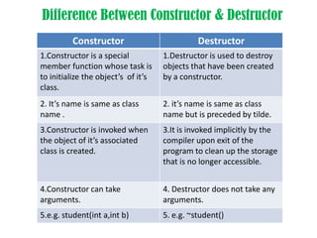
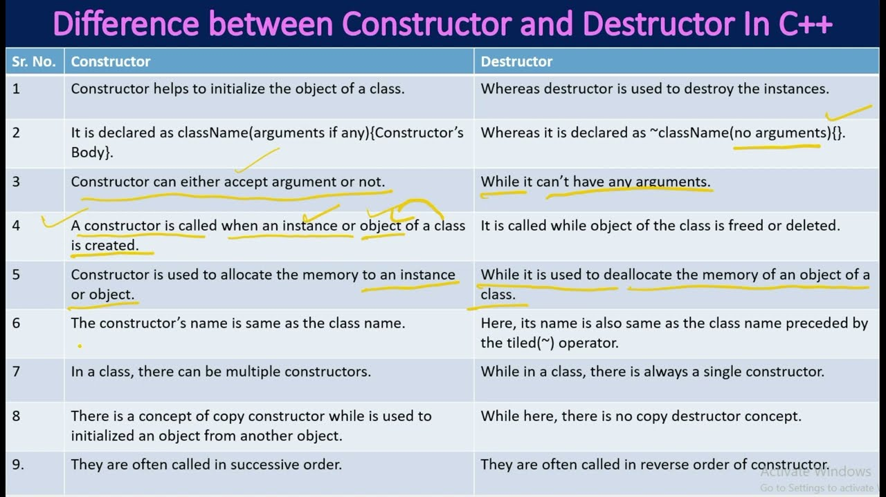

Friend Class and Function in C++
A friend class can access private and protected members of other classes in which it is declared as a friend. It is sometimes useful to allow a particular class to access private and protected members of other classes. For example, a LinkedList class may be allowed to access private members of Node.
function is defined as a friend function in C++, then the protected and private data of a class can be accessed using the function.
By using the keyword friend compiler knows the given function is a friend function.
For accessing the data, the declaration of a friend function should be done inside the body of a class starting with the keyword friend.
Characteristics of a Friend function:
- The function is not in the scope of the class to which it has been declared as a friend.
- It cannot be called using the object as it is not in the scope of that class.
- It can be invoked like a normal function without using the object.
- It cannot access the member names directly and has to use an object name and dot membership operator with the member name.
- It can be declared either in the private or the public part.
#include<iostream>
using namespace std;
class hello{
private:
int a;
int b;
friend void hi(hello);
};
void hi(hello s1)
{
cout<<"enter the first value"<<endl;
cin>>s1.a>>s1.b;
cout<<s1.a+s1.b<<endl;
}
int main()
{
hello s2;
hi(s2);
}

Friend class
A friend class can access both private and protected members of the class in which it has been declared as friend.
When a class is declared a friend class, all the member functions of the friend class become friend functions
A friend class in C++ can access the private and protected members of the class in which it is declared as a friend. A significant use of a friend class is for a part of a data structure, represented by a class, to provide access to the main class representing that data structure
#include <iostream>

using namespace std;

class A
{
int x =5;
friend class B; // friend class.
};
class B
{
public:
void display(A &a)
{
cout<<"value of x is : "<<a.x;
}
};
int main()
{
A a;
B b;
b.display(a);
return 0;
}

C++ Pointers
Pointers are symbolic representations of addresses. They enable programs to simulate call-by-reference as well as to create and manipulate dynamic data structures. Iterating over elements in arrays or other data structures is one of the main use of pointers.
The address of the variable you’re working with is assigned to the pointer variable that points to the same data type (such as an int or string)

How to use a pointer?
- Define a pointer variable
- Assigning the address of a variable to a pointer using the unary operator (&) which returns the address of that variable.
- Accessing the value stored in the address using unary operator (*) which returns the value of the variable located at the address specified by its operand.
// C++ program to illustrate Pointers

#include <bits/stdc++.h>
using namespace std;
void geeks()
{
int var = 20;

// declare pointer variable
int* ptr;

// note that data type of ptr and var must be same
ptr = &var;

// assign the address of a variable to a pointer
cout << "Value at ptr = " << ptr << "\n";
cout << "Value at var = " << var << "\n";
cout << "Value at *ptr = " << *ptr << "\n";
}
// Driver program
int main()
{
geeks();
return 0;
}

